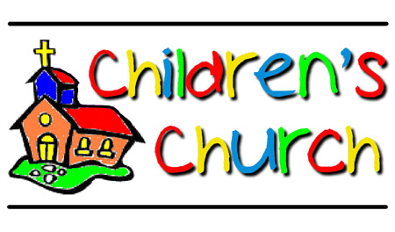
Children’s Church
September and October Schedule

September 22nd – Lisa Kerby
September 29 – Mary Martha Edwards
October 6 – Linda Richards
October 13- Megan Westby/ Donna Garrison
October 20 – Lisa Kerby
October 27 –Cathryn Borer

